Change log Apr 28, 2025;

Current Best M; merge because criterion 1-20 go down.

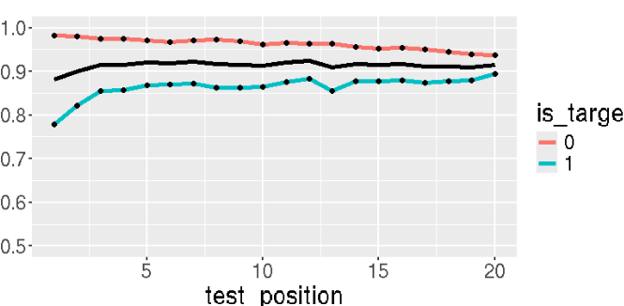

Try 1: take away criterion change. (should make flat)

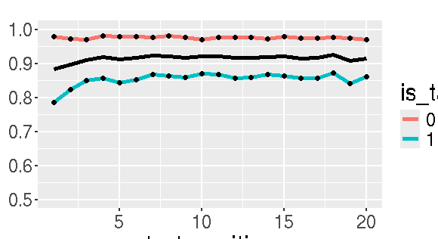

Try 2: try 1+ perfect (better) restorage in initial test (make later T have even lower odds, thus decrease Hits) => doesn’t change much, maybe gives a little? (p_recallFeatureStore = 1) from 0.85 origial value
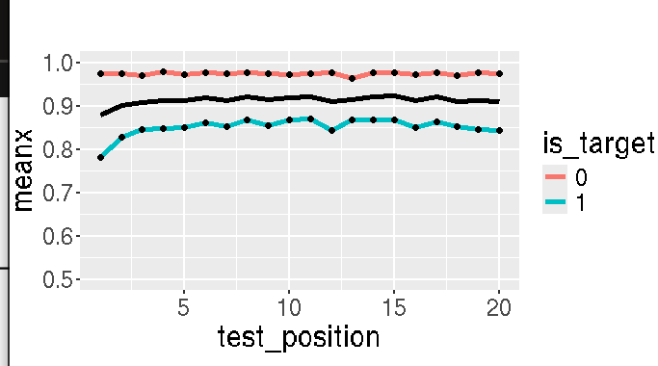

Try3: Try1+Try2+Add less trace (don’t add trace, see if try 2 better) – not doing anything;
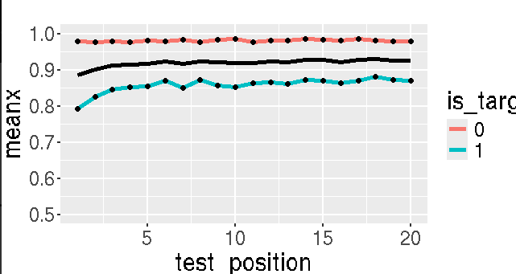
Try 4: Pass more item from last list + Try 1 (criterion flat)
context_tau = 100; go from 100 to 1;

